**Gephi Algorithms Betweenness Centrality, PageRank, and Modularity Explored**

Janis Corona

Kent LaFary

Lewis University

**Abstract** This report is on the use of Gephi software that analyzes data found online and for free exploring three of the metrics algorithms Betweenness Centrality, PageRank, and Modularity. The data visualizations in this document were prepared with the Gephi software using insights on data networks and network trees [1],[2].

*Index Terms*— Betweenness, digraph, directed graph, edges, modularity, nodes, page rank, path length, trees, undirected graph, weighted graph

1. INTRODUCTION[1]

This report is on exploring and defining the metrics data analysis algorithms that the software Gephi provides. Three of the algorithms explored will be the most common metrics used for social network analysis and scale free networks called Betweenness Centrality, Modularity, and PageRank [3]. The datasets are network social datasets found online and for free.

1. DESCRIPTION OF THE DATASETS

## Data Retrieval for Three Network Datasets

One of the three datasets is a network of the Marvel superhero comic book characters that was downloaded from a github site that had the other two datasets among other datasets for network data to use in Gephi [4]. This dataset has 10469 nodes and 178115 edges. A very large dataset that takes more time to load than the other two. See Fig. 1a and Fig. 1b for the network overview of this dataset.



Fig. 1a: The Marvel superhero network in entirety as viewed in Gephi.



Fig. 1b: The zoomed in Marvel superhero network dataset in Gephi. Invisible Woman/Sue and Iron Man/Tony Stark are visible as nodes in this network.

One of the other datasets is a dataset representing the neural network of a C. Elegans compiled by D.J. Watts and S.H. Strogatz before 1986 [5]. This dataset has 306 nodes and 2359 edges. See Fig. 2 for a screenshot of this network in Gephi.



Fig. 2: Screenshot of the Neural networks overview in Gephi.

The other dataset is a network of gene related diseases that show a relationship of a disease being linked to a genetic factor having a higher gene and product interactivity and gene transcripts with higher expression profiling similarity [6]. This dataset has 1419 nodes and 3926 edges. See Fig. 3 for the network overview of this dataset.



Fig. 3a: The Disease-Gene dataset zoomed out with labels added.



Fig. 3b: The zoomed in Gephi screenshot of the disease-gene dataset with labels added.

III. DESCRIPTION OF THE ALGORITHMS

B. The PageRank Algorithm

The PageRank algorithm is a metric that gives a probability of each node that represents a page in a network being at that node’s page after a certain number of clicks. This algorithm is one that uses an adjacency matrix with normalized columns and the highest page rank eigenvalue in the eigenvector corresponding to this matrix [7].

The algorithm for PageRank value of a particular web page is to take the set of all web pages linking to that particular web page and divide by the number of links each page in the set making the page rank of this particular web page depend on the page rank of each page in the set containing that particular web page [8]. See Fig. 4a and 4b for the Gephi statistic panel feature PageRank on the disease-gene dataset.



Fig.4a: The disease-gene dataset using the PageRank algorithm in Gephi.



Fig. 4b: The results of running the PageRank algorithm on the disease-gene dataset in Gephi.

C. The Betweenness Centrality Algorithm

The measure of how often a node appears on shortest paths between nodes in the network is node betweenness centrality [9].

The Betweenness Centrality Algorithm is based on order theory, where a collection of input ordered triples of items is used to determine an output of ordered items where the middle items location between the first and last ordered items in each set is satisfied in the output ordering [10].

As an example, if there are three ordered sets {1,3,5},{4,3,9},{1,6,9}, then an output could be {1,4,3,5,6,9} but not {1,9,3,6,5,4} since the ordering places 3 between 1 and 9, then also between 1 and 5, and also between 4 and 9.

In Gephi you will look for this algorithm by the name betweenness centrality and be disappointed because the Gephi name for this algorithm in the statistics panel is called Avg. Path Length. See Fig. 5a through Fig. 5e for the Betweenness Centrality measure of the Marvel Superhero dataset.



Fig. 5a: The Avg. Path Length statistic that is the alternate name for the Betweenness Centrality algorithm in Gephi.



Fig. 5b: The Betweenness Centrality graph is the first graph that shows after running the Avg. Path Length algorithm on the Marvel Superhero dataset.



Fig. 5c: The Closeness Centrality Distribution of the Avg. Path Length feature algorithm in Gephi on the Marvel superhero dataset.



Fig. 5d: The Harmonic Closeness Centrality Distribution of the Avg. Path Length statistic in Gephi on the Marvel Superhero dataset.



Fig. 5e: The Eccentricity Distribution chart on the Marvel Superhero dataset using the Avg. Path Length statistic in Gephi.

D. The Modularity Algorithm

The Modularity algorithm measures how well a network decomposes into modular communities with the highest modular score indicating a more sophisticated network [11]. Modularity is also called a community structure that has been shown to have real world meanings [11]. See Fig. 6a and Fig. 6b for the Gephi Modularity algorithm on the Marvel superhero dataset.



Fig. 6a: The modularity statistic on the Marvel superhero dataset in Gephi.



Fig. 6b: The Modularity report on the Marvel superhero dataset in Gephi.

1. VISUALIZING RESULTS

E. The Disease-Gene dataset explored with PageRank, Modularity, and Betweenness Centrality

When exploring the disease-gene dataset in Gephi, the Force Atlas layout view was used to show a better visual of the network nodes spread out. See Fig.7 for an image of the disease-gene dataset after running the Force Atlas layout.



Fig. 7: The spread of the disease-gene data after running the Force Atlas layout at the left side of the Gephi software.

The PageRank algorithm on the disease-gene dataset shows the page rank of each disease in a table view by going to the Data Laboratory tab of Gephi [12]. When running PageRank in Gephi when prompted the results are from using the default epsilon of 0.001, the undirected nodes and not selecting the option to use edges by weight. If you run the Force Atlas Layout before selecting the PageRank algorithm the results differ than not using the Force Atlas Layout.

The results for the page rank score before running Force Atlas are seen in Fig. 8a, but when running the PageRank algorithm after running the Force Atlas Layout the score for node 114 was larger at 0.0103 instead of 0.0054 before running the Force Atlas Layout. See Fig. 8a for the table of this data and Fig. 8b for the zoomed in and labeled nodes corresponding to the highest ranked disease in the data. The highest page rank score is for colon cancer, which is node 114. This means other diseases link to colon cancer from this data.

The table view is more interesting and informative than looking at the chart of the data. The chart only gives data points for two options of either zero or one. All the points are counts accumulated at zero. See Fig. 9 for the chart of the disease-gene data.

When done the image was exported as SVG in an html format that check marked the labels and used Arial font size 3. See Fig. 10 for an image of this file.



Fig. 8a: The table view of the Disease-gene dataset after running the PageRank algorithm in Gephi. There is a higher score for the node 114 for colon cancer in this dataset of diseases.



Fig. 8b: The zoomed in and labeled colon cancer node showing many edges or relationships with other diseases.



Fig. 9: The chart of the Disease-gene dataset in Gephi after running the PageRank algorithm without checking the use edges as weights checkbox, and with an epsilon of 0.001 and undirected nodes.



Fig. 10: The exported SVG image is too large to put in this Word document because it takes too long to load. This image is a partial screenshot of the exported SVG file with the edges curved and visible, as well as the labels in Ariel size 3.

When running the Modularity algorithm on the disease-gene dataset, there ended up being 29 classes from 0 to 29. This score means there are 29 communities within these genes and diseases that the nodes have been grouped into. Many of the genes and diseases are in groups together. This means they are closely related to each other and any information shared like a marketing campaign can pass through one strongly connected node through its community.

When running the Avg. Path Length algorithm to access the Betweenness Centrality algorithm, there were zero results for the genes but normalized results for the diseases with the lowest score for Leukemia and the highest for cardiomyopathy. The table was exported as a spreadsheet in csv or tsv format to evaluate the results.

H. The Neural networks dataset explored with PageRank, Modularity, and Betweenness Centrality

When running the PageRank algorithm with the directed edges and not using edge weights on the neural network dataset, the results showed a normalized chart with nodes bunched up closer to zero, but not all on zero. See Fig 11 for this image of the PageRank chart. The results for the nodes in scoring the page rank is that node 304 scores the highest with 0.124, and many nodes have a page rank score of 0.00094, meaning they aren’t as highly associated with other nodes in the network. The rank of 0.00094 is the lowest value in the page rank statistics.



Fig. 11: The PageRank chart of the directed nodes in the neural network dataset.

When running the Modularity algorithm on the neural network dataset, after running PageRank, there are 15 communities and a modularity of 0.386. See Fig. 12 for this chart.



Fig. 12: The Modularity results on the neural networks dataset.

Using the Avg. Path Length statistic to access the Betweenness Centrality algorithm produced with directed nodes and normalized results to show that the average path length is 3.99, the radius is zero, and diameter is 14. See Fig. 13 for a chart of the Betweenness Centrality algorithm results.



Fig. 13: The Betweenness Centrality Distribution results on the neural networks dataset.

The image was then saved with the edges curved, Arial font size 5 on the labels, and as SVG. A screenshot is shown in Fig. 14.



Fig. 14: A partial screenshot of the exported image of the neural networks dataset with curved edges and weighted nodes with their label values.

K. The Marvel superhero dataset explored with PageRank, Modularity, and Betweenness Centrality

Running the PageRank algorithm on the Marvel superhero dataset on undirected nodes and the default 0.001 epsilon and 0.85 percent probability without checking the use of edge weights, produced a normalized chart with a count of values between zero and one. The values are all gathered around zero for counts as high as almost 140. See Fig. 15 for this image screenshot.



Fig. 15: The PageRank chart of the Marvel superhero dataset in Gephi.

The table values for PageRank of the Marvel superhero dataset is more informative. Ironman/Tony Stark has the highest page rank normalized score of 0.0087, and the lowest normalized score is shared amongst many side characters like rogue doppelganger or Captain Fate at 0.000016.

Running the Modularity algorithm on the Marvel dataset of superheroes using randomized and the other default setting gave the community associations of the strongest superhero networks. There are 35 communities, with a modularity score of 0.491 using weighted edges and randomization. See Fig. 16 for this chart of Modularity results.



Fig. 16: The Modularity results on the Marvel superhero dataset. More of the nodes of superheroes are in community two, and the communities higher than 17 all have one or very low counts in their communities.

When viewing the table results of the Modularity results on the superhero dataset, the highest ranked node for Iron Man belongs to community two. The lower ranking nodes belong to groups 1,2,3,4,5,6,9, and 12.

The last algorithm to run on the Marvel dataset of superheroes is the Avg. Path Length to get access to the Betweenness Centrality algorithm. When running this statistical algorithm, the results were chosen to be normalized and on the undirected nodes. This process takes a much longer time, because this dataset is the largest of the three with 117,885 edges and 10,469 nodes. This is not an exaggeration that it takes more than five minutes to load but at least with a progress bar showing the status in the lower right corner of the screen. See Fig. 17 for an image of the Betweenness Centrality results showing all the count values bunched around zero in the normalized average path length values. The average path length is 2.889 with radius 1 and diameter 7 on undirected nodes of superheroes.



Fig. 17: The normalized chart results of the Betweenness Centrality algorithm used on the Marvel superhero dataset.

The highest Betweenness Centrality score is at 0.0703 for Iron Man, and the lowest normalized score is 0.0 shared amongst many nodes of superheroes that aren’t just the lowest scored page rank characters. See Fig. 18 for a screenshot of the table this algorithm produced.



Fig. 18: The screenshot of the Marvel Superhero dataset zoomed into the highest scoring page rank character Ironman.

This file was exported to spreadsheet form as a table and an image was exported of this large network in SVG format with curved edges displayed as well as the text in Arial size 3. The size of the SVG file was too large to save in memory, 114,000Mb or 114 GB is how large the file was going to be when exporting the network topography out layout to an image. partial area of the SVG image zoomed into Iron Man. The preview tab allows customization which was done on the node color, opacity of edges, and thickness of borders of nodes. See Fig. 19 for the image of the layout of the Marvel superheroes network with Force Atlas 2 layout and zoomed into the top-ranking character Ironman in this dataset for Betweenness Centrality.

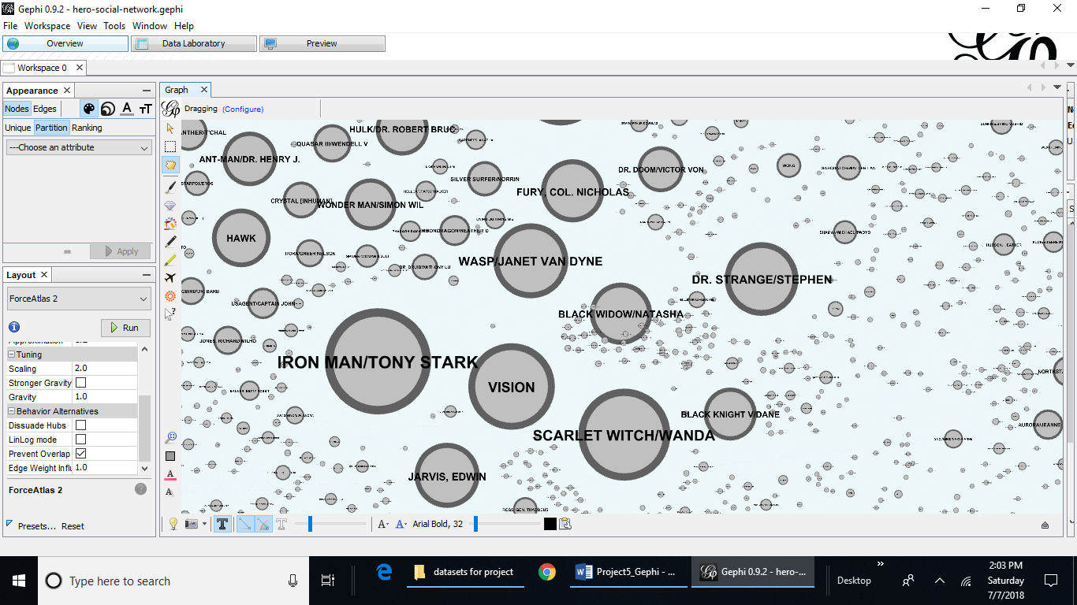

Fig. 19: The layout design of the Marvel superhero dataset network of superheroes that Marvel produces. Iron Man is the highest ranked superhero in Page Rank, Modularity, and Betweenness Centrality.

1. CONCLUSION

This project looked at three of the algorithms that Gephi provides on three different datasets. PageRank, Betweenness Centrality, and Modularity were used separately on each of three different network datasets that contained an anonymous person’s neural network mapping, a Marvel superhero dataset of all superheroes Marvel has created including the minor roles, and a network dataset on the relation of genes mapped out with various diseases.

All the datasets were interesting, but the very large Marvel dataset was too large to export as an SVG file. The information gathered on the datasets using PageRank showed in tabular format as well as graphically as a layout the nodes or characters in the network with more ties to other nodes or influence on other nodes in the network. The Modularity algorithm showed the communities that nodes belonged to and the Betweenness Centrality algorithm showed ties or relationships between other nodes in the network.

All of these features of Gephi make it great software suite to analyze the network datasets for information on connections between different members of the network. The social networks could be used for marketing campaigns or investigations into criminal networks or researching family trees among many other uses.

1. REFERENCES

[1] Gephi v.0.9.2 software download. Retrieved on June 28, 2018 from <https://gephi.org/users/download/>

[2] M. Lewis. Week 7: Trees and Networks [PowerPoint]. Retrieved on June 25, 2018 from <https://lewisuniversity.blackboard.com/bbcswebdav/pid-3208882-dt-content-rid-23195753_1/xid-23195753_1>

[3] Features. “Metrics” retrieved on June 30, 2018 from <https://gephi.org/features/> .

[4] C. Rosselló, R. Alberich, and J. Miro from the University of the Balearic Islands. Collected by Infochimps and transformed & enhanced by Kai Chang. Hero-social-network.gephi [gephi dataset]. “The Marvel Social Network” retrieved on July 4, 2018 from <https://gephi.org/datasets/hero-social-network.gephi>

[5] D. J. Watts and S. H. Strogatz, Nature 393, 440-442 (1998). Original experimental data taken from J. G. White, E. Southgate, J. N. Thompson, and S. Brenner, Phil. Trans. R. Soc. London 314, 1-340 (1986). celegans.gexf [dataset]. The C.Elegans Neural Network. Retrieved on July 4, 2018 from <http://gephi.org/datasets/celegans.gexf.zip>

[6] The Human Disease Network, Goh K-I, Cusick ME, Valle D, Childs B, Vidal M, Barabási A-L (2007), Proc Natl Acad Sci USA 104:8685-8690. Retrieved on July 4, 2018 from <http://gephi.org/datasets/diseasome.gexf.zip>

[7] S. Heymann, March 1, 2015. “PageRank.” Retrieved on June 30, 2018 from <https://github.com/gephi/gephi/wiki/PageRank>

[8] “PageRank” [Wiki]. Retrieved on June 30 2018 from <https://en.wikipedia.org/wiki/PageRank>

[9] S. Heymann March 1, 2015. “Betweenness Centrality.” Retrieved on June 30, 2018 from <https://github.com/gephi/gephi/wiki/Betweenness-Centrality> .

[10] “Betweenness” [Wiki]. Retrieved on July 1, 2018 from <http://en.wikipedia.org/wiki/Betweenness#Betweenness_centrality> .

[11] S. Heymann March 2, 2015. “Modularity.” Retrieved on July 1, 2018 from <https://github.com/gephi/gephi/wiki/Modularity>

[12] D.Yim. Calculating Page Rank with Gephi-Mac [Youtube]. February 10, 2014. Retrieved on July 4, 2018 from <https://www.youtube.com/watch?v=A6fKPzdWLqI>

1. This paper was submitted on July 8, 2018 for review.

   Janis Corona is a Data Science graduate student at Lewis University, One University Pkwy, Romeoville, IL 60446 USA (e-mail: jcorona@Lewisu.edu).

   Kent LaFary is a Data Science graduate student at Lewis University, One University Pkwy, Romeoville, IL 60446 USA (e-mail: Klafary@Lewisu.edu).